|  |  |
| --- | --- |
| **Name** | Muhammad Asad |
| **Reg. No** | 2019-EE-383 |
| **Marks/Grade** |  |

**Objective:**

**EXPERIMENT # 2**

# Modeling of Over Current Relay

At the end of this lab session students will be able to

* Use “SimPowerSystems” for modeling the power system.
* Implement “Over Current relay” by using Matlab Simulink Libraries.
* Set the “Current Setting” of Over Current Relay.
* Learn how to create an electrical subsystem.

### Introduction:

Utilities are responsible for the generation, transmission and distribution of electricity to customers. Part of this responsibility is ensuring a safe but yet reliable power supply to customers. For the purpose of safety and protecting the transmission and distribution network from faults, utilities worldwide have sophisticated protective equipment. Collectively, these are known as secondary equipment and include the current transformers (CT), potential transformer (PT) and protective relays.

### Protective relays:

A protective relay is one which monitors the current, voltage, frequency or any other type of electric power measurement either from a generating source or to a load for the purpose of triggering a circuit breaker to open in the event of an abnormal condition. In the electrical power system these relays are called as protective relays.

The function of protective relaying is to cause automatic removal of a part of the system, when it suffer a short circuit, or when it starts to operate in an abnormal manner that might cause damage or otherwise interference with the effective operation of the rest of the system. Relays are also used for the prompt removal of any part of the system from the service, for the purpose of maintenance.

### Circuit Breakers:

Circuit breakers are generally located so that each generator, transformer, bus, transmission line, etc. can be completely disconnected from rest of the system. These circuit breakers must have sufficient capacity so that they can carry momentarily the maximum short- circuit current that can flow through them, and then interrupt this current.

### Over Current Relay:

Over current relay is one which monitors the current only and gives trip signal to the circuit breaker in faulty (short circuit) condition. In case of short circuit faults, current in the system increases from its normal value. This short circuit current can be many times greater than the full load current. The magnitude of short circuit current depends upon the fault impedance and other parameters of system.

### Laboratory Task:

***Implement over current relay in Matlab Simulink that protect the system in short circuit faults. After sensing the fault relay should give a trip signal to the circuit breaker.***

### Procedure:

**Step 1:** Draw a simple power system having a **3-φ** source, **3-φ** phase circuit breakers, **3-φ** VI Measurement unit, **3-φ** RLC series load and block of **3-φ** fault to implement different types of fault in system. Connect the blocks as shown below.

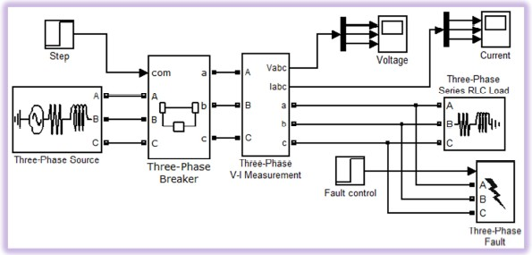

Set the parameters of each block as mentioned below. Accept default values for all other Parameters.

Total Simulation Time:

Solver: Ode23tb (stiff/TR-BDF2)

***Note: To select the solver go to menu bar > Simulation > Configuration Parameters OR press (Ctrl***

***+ E) and select the solver. Also set following solver options.***

Relative tolerance: 1e-3 (default)

Solver reset Method: Robust

System Frequency: 50 Hz

See "*Improving Simulation Performance*" chapter in SimPowerSystems documentation for additional information on how to select an appropriate integration method (Solver).

#### Three phase source:

Voltage (Phase to Phase): 11e3 V Internal connection: Y grounded

Specify impedance using short-circuit level: Select this option

**(*This option is selected to specify internal impedance using the inductive short-circuit level and X/R ratio.*)**

3 phase short circuit level: 500e6 VA

The three-phase inductive short-circuit power, in volts-amperes (VA), at specified base voltage, is used to compute the internal inductive reactance **X**. This parameter is available only if Specify impedance using short circuit level is selected.

The internal inductance L (in H) can be computed by using the inductive three-phase short circuits power P**sc** (VA), phase-to-phase base voltage Vbase (V), and source frequency f (Hz) as follows:



Base voltage: 11e3 V

X/R ratio: (keep default value)

This parameter is available only if **Specify impedance using short circuit level** is selected. The internal resistance **R** (in Ω) is computed from the source reactance **X** (in Ω) at specified frequency and **X/R** ratio as follows:



#### Three-Phase Breaker:

Initial status of breakers: closed Enable switching of all Phases

External control of switching times: Select this option Measurements: None

Breakers resistance **Ron:** 0.001

Snubber’s resistance **Rp:** 1e6

Snubber’s capacitance **Cp**: inf

#### Three-Phase V-I Measurement:

Voltage measurement: phase-to-phase Current measurement: Yes

(Uncheck **labels** and **per-unit** measurements)

#### Three-Phase Series RLC Load:

Configuration: Y grounded

Nominal voltage: 11e3 V

Active Power (MW): **200e6** W Inductive reactive power: 100 VAR Capacitive reactive Power: 0 VAR

#### Three Phase Fault:

Ground fault: Select this option External control of fault timing: Select this option Initial status of fault: [0 0 0]

#### Step Sources:

There are two step sources used in this model to control the circuit breaker and fault blocks. Their step time and initial value have been set in such a way that “breaker” remains close up to 0.16s and “fault” does not occur during complete simulation time. As simulation time is 0.3s and step-time of “Fault Control (Step source)” is 1s. It means the output of this step source will remain “0” during simulation time.

|  |  |
| --- | --- |
| **Step:**  Step time: | 0.16 |
| Initial value | 1 |
| Final value | 0 |
| **Fault Control:**  Step time: | 1 |
| Initial value | 0 |
| Final value | 1 |

Run the simulation and observe the current and voltage wave form on Scope. Find the peak value of current and voltage in each phase when the circuit breaker is close and note in the space given below.

### Simulink model:

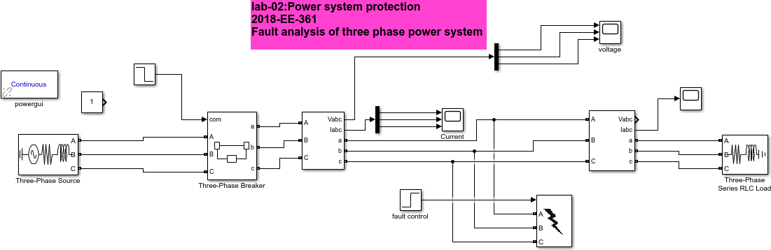

Fault analysis of three phase power system

**Fig.1 show the Simulink model of three phase power system fault analysis**

### Current waveform:

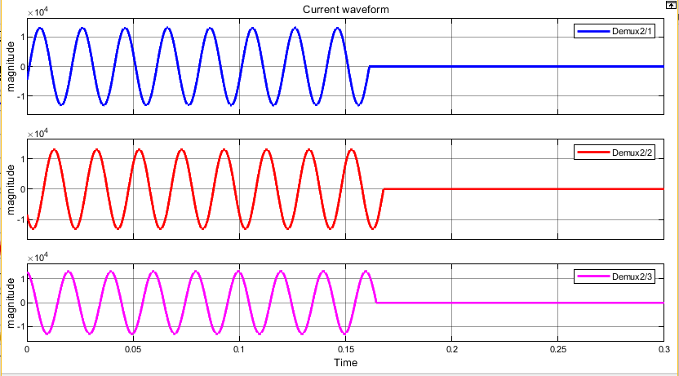

**Fig.2 show the current waveform tripping at 0.16sec**

### Voltage Waveform:

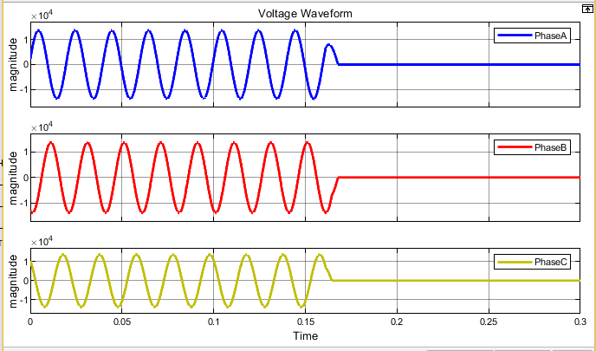

**Fig.3 show the voltage waveform tripping at 0.16sec**

* Connect the RMS block in each phase of output current and find rms value of current in Each phase.
* Different RMS blocks are available in Matlab Simulink libraries. Select appropriate RMS block that has constant output.
* Find the steady state RMS value of currents by using “powergui” block. Now compare the RMS value of current observed on the scope with its exact value obtained from its steady state

Analysis.

### Simulink model:

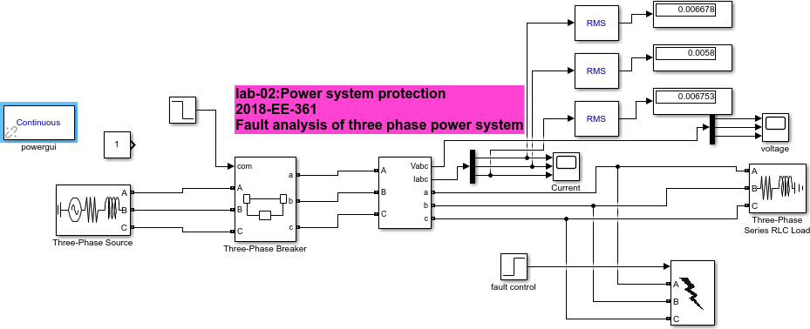

Fault analysis of three phase power system

**Fig.4 show the Simulink model of three phase power system fault analysis for RMS value calculation**

* We observe that the steady state values via RMS block are less than the steady state values obtained via powergui.

**Step 2:** The rms value of current, observed in Step 1, is rated load current of the system. System can be overloaded up to 40%. So over current relay must not consider this over loaded condition as faulty condition. But as soon as current exceed this over loading limit, over current relay must trip the circuit breakers.

To model this condition in Simulink compare the rms value of currents with constant. The value of constant will be 1.4 times of rms value of rated load current.

Insert a subsystem in the model. Rename this subsystem as “Over Current Relay”. Open this Over Current Relay (Subsystem). By default it has one input and one output port that is directly connected with each other. Add another input port and rename all the I/O ports as shown.

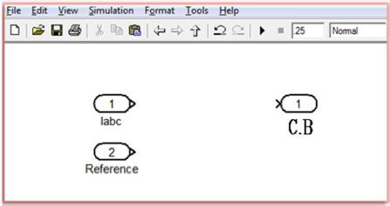

Add different block in this subsystem and connect with each other as shown in figure below.

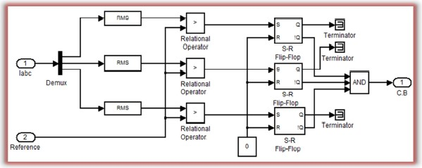

In above figure of “over current relay” RMS value of current is compared with a reference value. If the current is greater than the reference value then it is faulty condition and the output of “Relational operator” will be logic ‘1’. Logical inverse of this output can be fed directly to the control input of the circuit breaker. But there is a problem with this implementation.

In case of fault RMS value of current will be greater than the “reference” value and the Output of relational operator will open the circuit breaker. As soon as circuit breaker will be open, the current in the system will decrease to zero and RMS value of current will become less than the reference value. Again this is a condition of normal operation so the output of relational operator will change and it will close the circuit breaker again. As fault exists in the system again relay will give a trip signal to the breaker. This opening and closing of circuit breaker will go on, that is not required.

To avoid this *S-R Flip-Flop* is used between breaker and relational operator. These flipflops will retain the state. Initial condition (state of Q) is set to ‘0’, so ‘!Q’ will be ‘1’. See truth table and further detail about the operation of flip-flop in Matlab “Help”.

#### Mismatch data-type:

The default data-type of output of relational operators, flip-flops and logic operators is “Boolean”. To connect the blocks with each other the output data-type of first block must be Consistent with the input data-type of the following block.

Input data-type of breaker is ‘double’ and in this system breaker is connected at the output of logic AND gate. So to avoid this data-type mismatch the output data-type of logic AND gate must be ‘double’. This can be done either by connecting “data-type conversion” block at the output of Logic AND gate or by setting the output data-type of logic AND gate (‘double’). For further detail see the help of “Logic operator”.

Now connect the relay in the system as shown in the following figure. Set the “Step Time” 0.1s of fault control (step source). By setting this timing fault will occur at 0.1s.

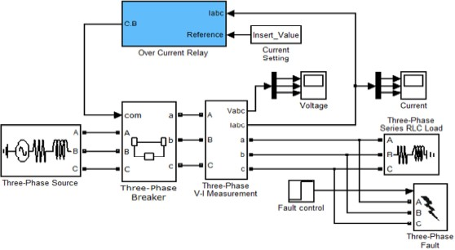

Check the output of “Over Current Relay” in following fault conditions.

1. **Single Line to Ground fault**
2. **Double Line to Ground fault**
3. **3-φ Grounded faul**

## Simulink model:

|  |  |  |
| --- | --- | --- |
|  | Fault analysis of three phase power system |  |
|  | | |

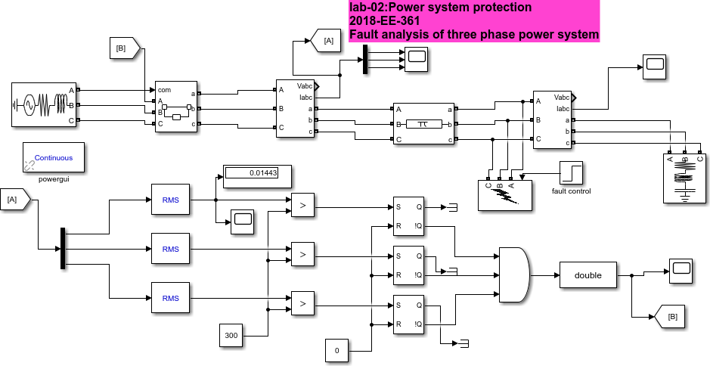**Fig.5 show the Simulink model of power system with overcurrent relay**

# Single Line to Ground fault

### Output current waveform:

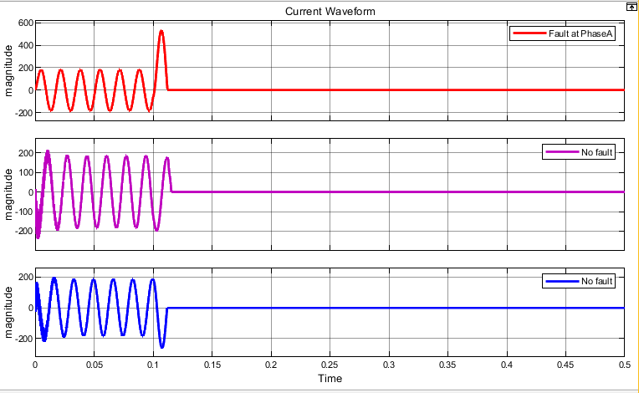

**Fig.6 show the current waveform of single phase fault occur at phase A at 0.1sec**

# Double Line to Ground fault

### Output current waveform:

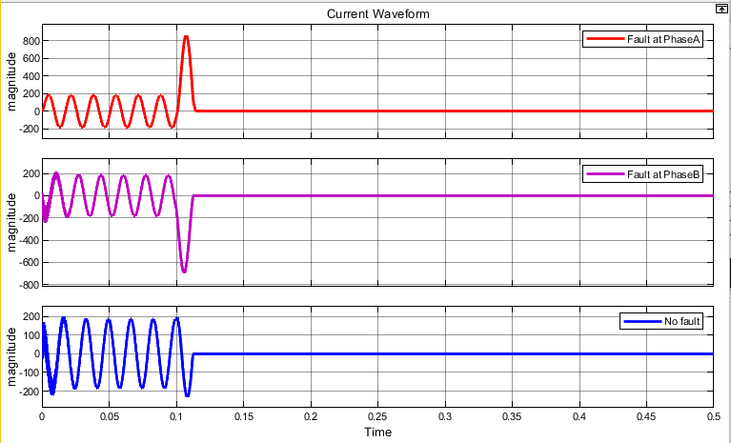

**Fig.7 show the current waveform of Double L-G fault at phase A and B at 0.1sec**

# 3-ⱷ Grounded fault

### Output current waveform:

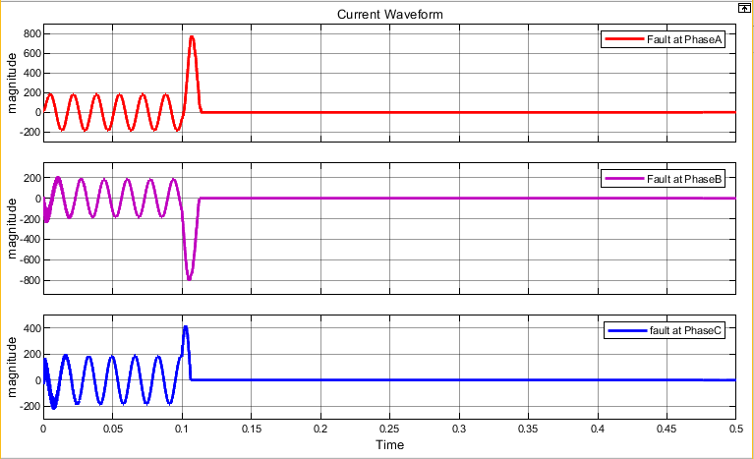

**Fig.8 show the current waveform 3-ⱷ grounded fault at 0.1sec**

### Assignment:

* Set total simulation time 0.5s.
* Then a fault should occur at t = 0.25s and relay must clear that fault.
* Attach printout of Modified Simulink model, output on scope and details of modification
* Screen shots of relay signal and input current and voltage before fault after fault.

### Modified Simulink model:

|  |  |  |
| --- | --- | --- |
|  | Fault analysis of three phase |  |
|  | | |

**Fig.9 show the Simulink model of power system with overcurrent relay**

### Relay signal:

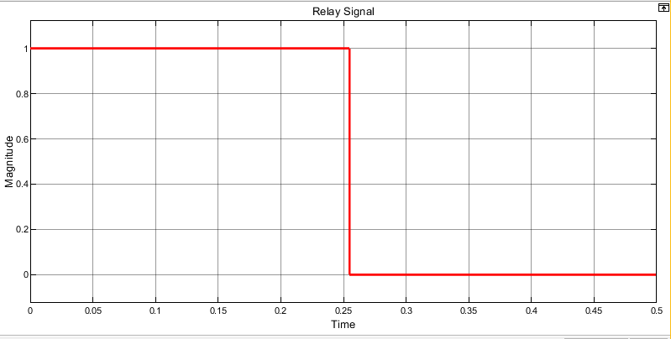

**Fig.10 show the relay signal that tripping the breaker at 0.25sec**

## INPUT CURRENT

### Before fault:

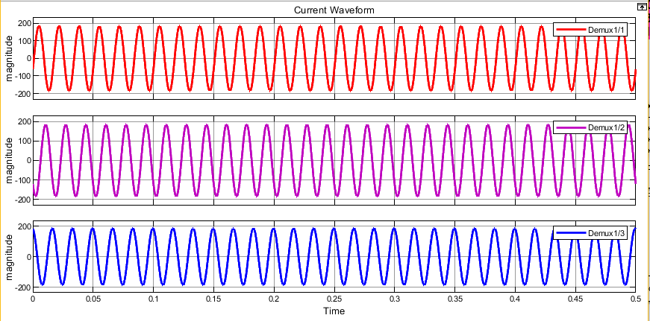

**Fig.11 show the three phase current waveform without fault insertion**

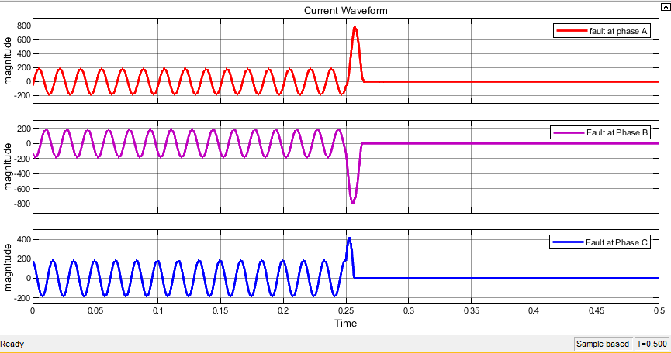

**Fig.12 show the three phase current waveform with fault insertion**

## INPUT VOLTAGE

### Before fault:

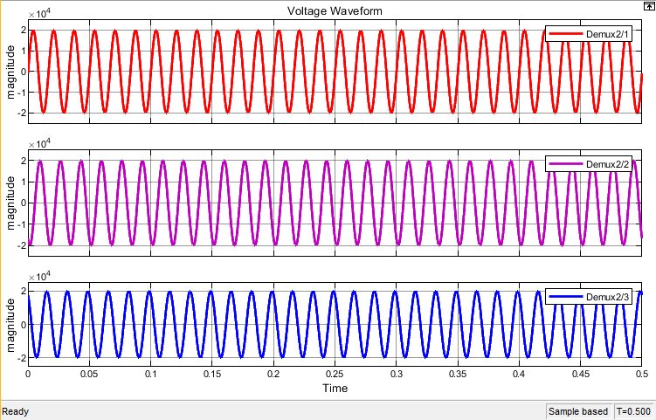

**Fig.13 show the three phase voltage waveform without fault insertion**

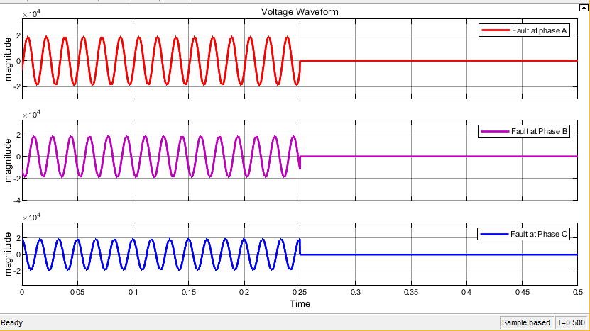

**Fig.14 show the three phase voltage waveform with fault insertion**

### Conclusion:

In this lab we studied about the designing of over current relay by using

MATLAB Simulink. In the first model there are two step sources used in this model to control the circuit breaker and fault blocks. We give different values to the both. In the second model we designed an overcurrent relay, we used a relay block whose function is to compare the three phase current with the reference value. In the third model (assignment) the circuit of second model is modified by adding a step in the Boolean and then both Boolean and step is given to AND operator. So, the output waveforms could be seen in between the that value given to step which is attach to Boolean and the value of step that we gave to fault block.